CSN Online Student Success Workshops – Free On-Demand
- Visit GoCSN and login with your CSN username and password (the same password you use for CANVAS).
- Click on the My Coyote Success tile to access the workshops.

ACADEMIC & CAREER EXPLORATION
Visit www.csn.edu and click LOGIN from the top menu.
Maximizing Your College Experience to Prepare For the Future [QS]
What It Takes To Be a Successful College Student [ES]
Exploring Careers & Choosing a Major [ES]
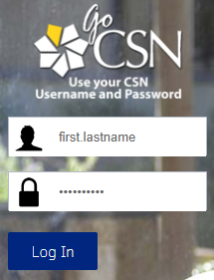
Mastering the Job Interview [ES]
Writing Effective Resumes & Cover Letters
Creating Your College Bucket List: Explore, Experience, Succeed

LEARNING TO LEARN
Discover Your Learning Style [ES] [QS]
Study Tips & Note-Taking Strategies: What Every College Student Should Know
How to Reduce Test Anxiety [ES]
Understanding & Avoiding Plagiarism [QS]
Learning Strategies Every Student Should Know [QS]
Exam Preparation Tips & Test-Taking Strategies
How to Overcome Math Anxiety
How to Succeed in Math
10 Habits of Mind for College Success
The Difference Between High School and College
Information Literacy: How to Master College Research
Academic Integrity: The Dos and Don’ts

ONLINE LEARNING
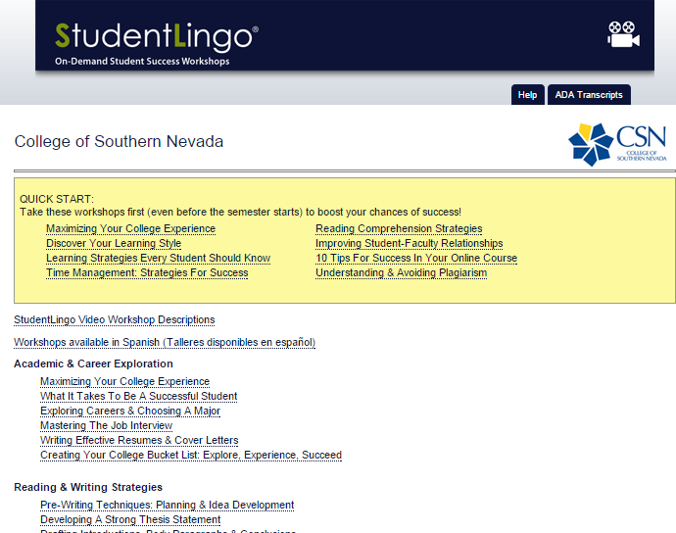
10 Tips for Success in Your Online Course [QS]
Effectively Communicating Online: Reading & Writing Strategies
How to Stay Motivated & Disciplined in an Online Course
Taking Tests Online: Strategies for Success

READING & WRITING STRATEGIES
Pre-Writing Techniques: Planning & Idea Development
Developing a Strong Thesis Statement
Drafting Introductions, Body Paragraphs & Conclusions
The Revision Process: How to Proofread & Edit Your Writing
Reading Comprehension Strategies (reading textbooks) [QS]

PERSONAL MANAGEMENT
Time Management: Strategies for Success [QS]
Overcoming Procrastination: Causes & Cures
Financial Literacy: Smart Money Skills for College & Beyond
Leave this window open
Stress Management Techniques: How to Minimize Stress in College
Navigating the Financial Aid Process [ES]
Improving Student-Faculty Relationships [QS]
How to Develop Your Cross-Cultural Skills
Setting & Accomplishing Realistic Goals
How to Achieve Well-Being, Balance & Success
Emotional Intelligence: The Other Key to Academic Success
Mental Health & Suicide: Helping Yourself & Others

SUCCESS STRATEGIES
Student Veterans: How to Succeed in College
Success Strategies for First Generation Students
Leading as a Student Athlete: In & Out of the Classroom

